**CSA1042: -SOFTWARE ENGINEERING FOR DATA SCEIENCE**

**NAME: B. Nikhil vardhan**

**Regno: 192211805**

**1Q. Draw a USE-CASE diagram for Online Voting System using CASE tools**

***Aim:*** To draw a use case diagram for online voting system using case tools.

***Software Used:*** Umbrello.

***Diagram:***

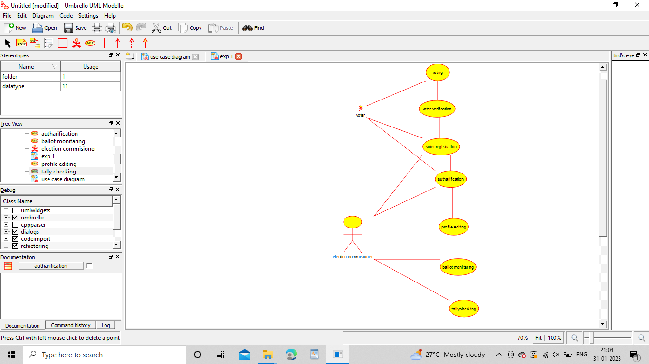

B. Nikhil Vardhan

192211805

1

**Result:** Drawing a use case diagram for online voting system was completed successfully.

**2Q. Draw a USE-CASE diagram for Library Management System using CASE tools.**

**Aim:** To draw a use case diagram for library management system using case tools.

**Software Used:** Umbrello.

**Diagram:**

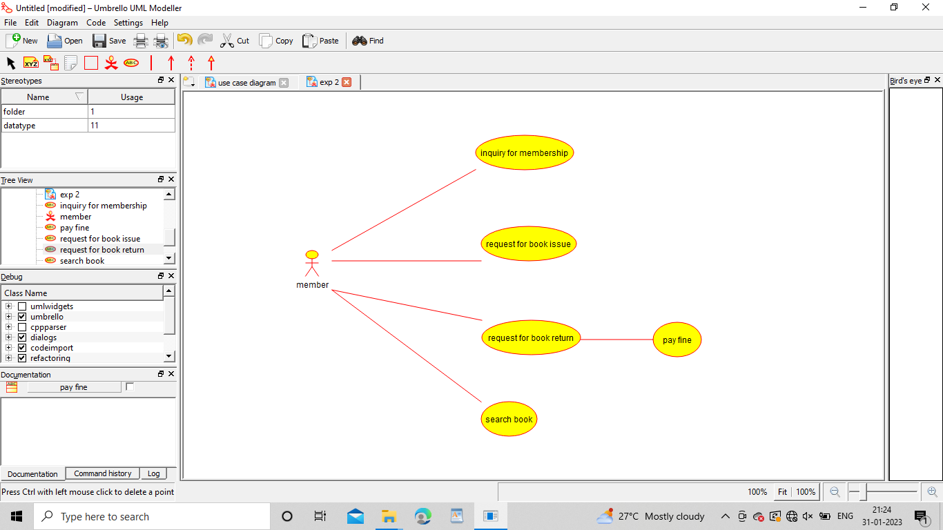

B. Nikhil Vardhan

192211805

**Result:** Drawing a use case diagram for library management system was completed successfully.

**3Q. Draw and validate the flowchart to compute the quotient and remainder.**

**Aim:** To draw and validate the flowchart to compute the quotient and remainder.

**Software Used:** Raptor.

**Diagram:**

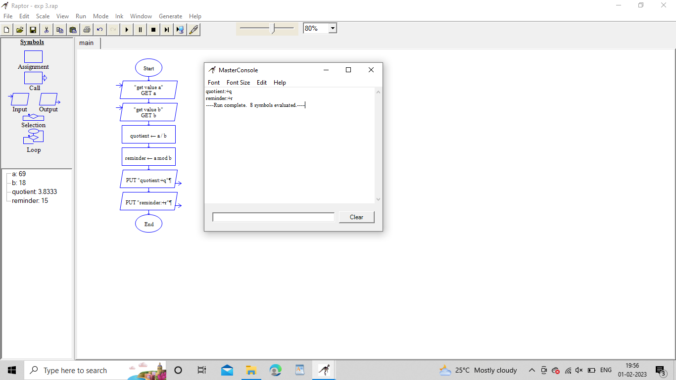

B. Nikhil Vardhan

192211805

**Result:** Flowchart to compute the quotient and remainder was completed and output verified.

**4Q. Draw a USE-CASE diagram for Online Shopping system using CASE tools.**

**Aim:** To draw a use case diagram for online shopping system.

**Software Used:** Umbrello.

**Diagram:**

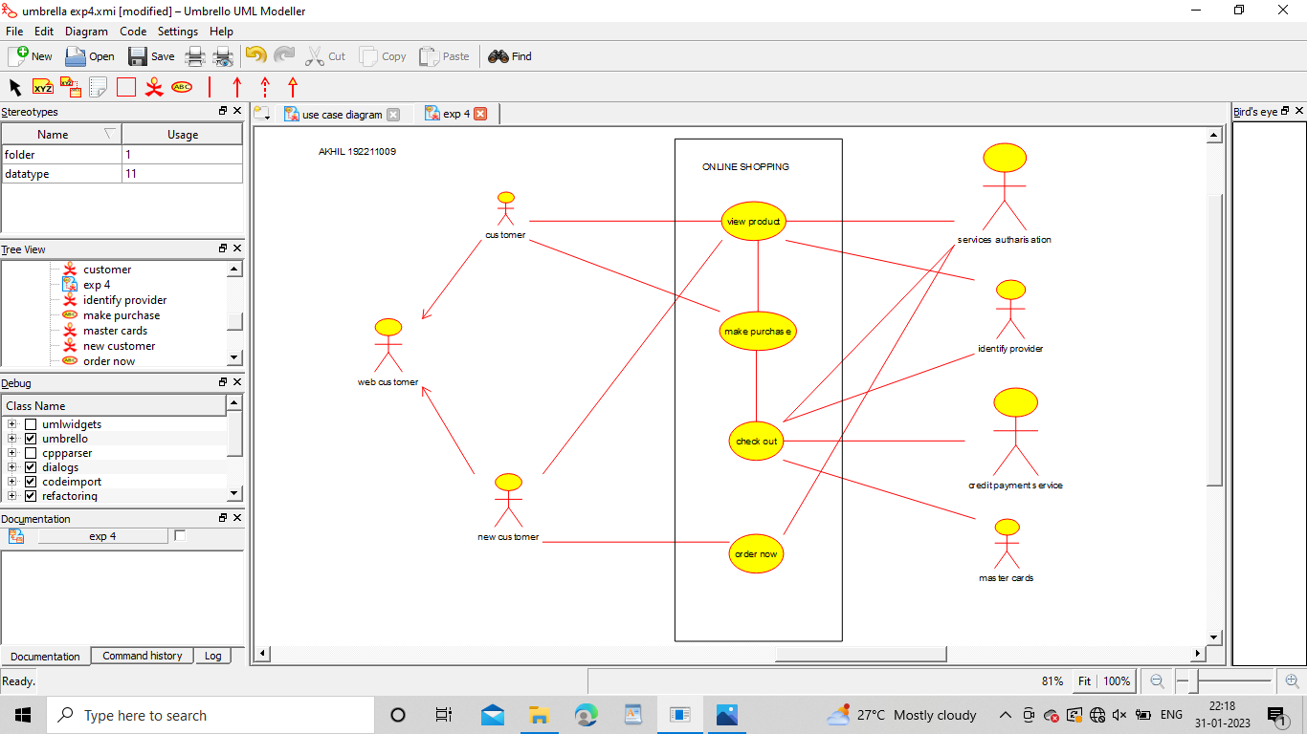

B. Nikhil Vardhan

192211805

**Result :** Drawing of use case diagram for online shopping voting system was successfully completed.

**5Q. Draw a USE-CASE diagram for Online Railway Reservation System using CASE tools.**

**Aim:** To draw a use case diagram for online railway reservation system.

**Software Used:** Umbrello.

**Diagram:**

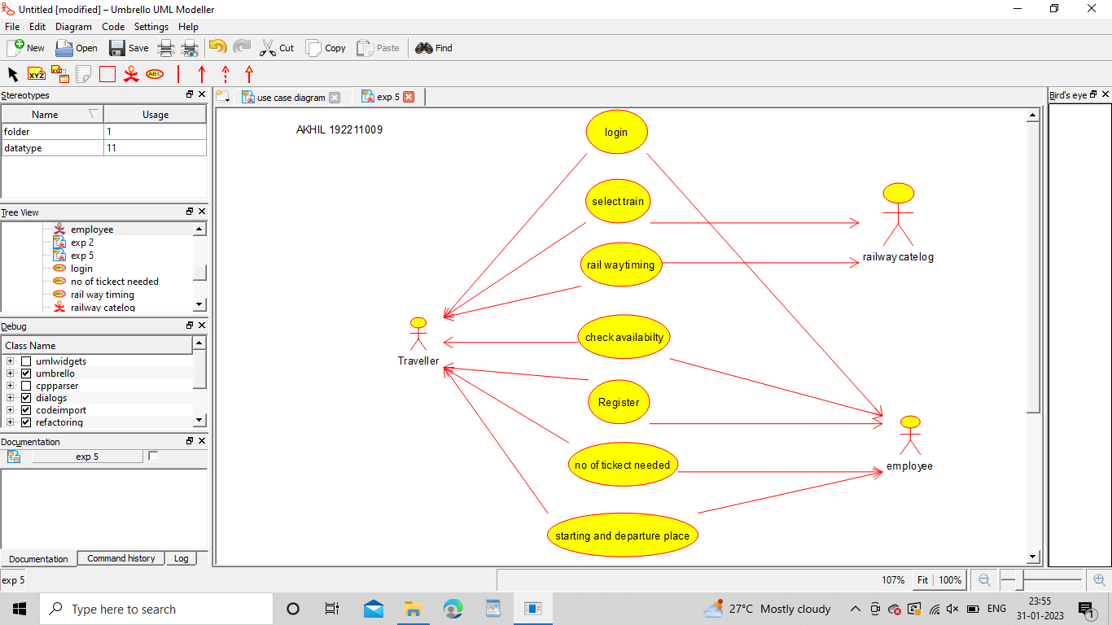

B. Nikhil Vardhan

192211805

**Result :** Use case diagram for online railway reservation system was successfully completed.

**6Q. Draw a USE-CASE diagram for Hospital Management System using CASE tools.**

**Aim:** To draw a use case diagram for hospital management system.

**Software Used:** Umbrello.

**Diagram:**

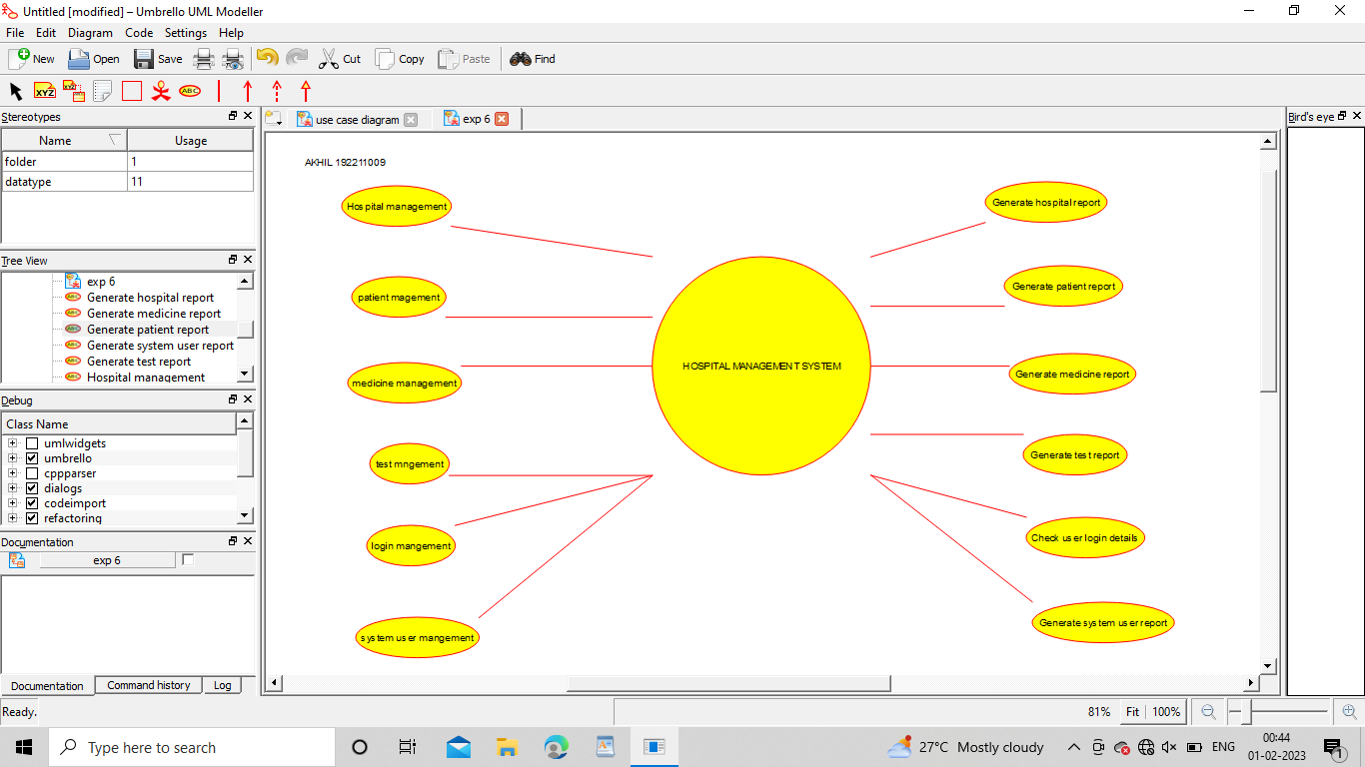

B. Nikhil Vardhan

192211805

**Result :** Use case diagram for hospital management system was successfully completed.

**7Q. Draw a USE-CASE diagram for ATM System using CASE tools.**

**Aim:** To draw a use case diagram for ATM system.

**Software Used:** Umbrello.

**Diagram:**

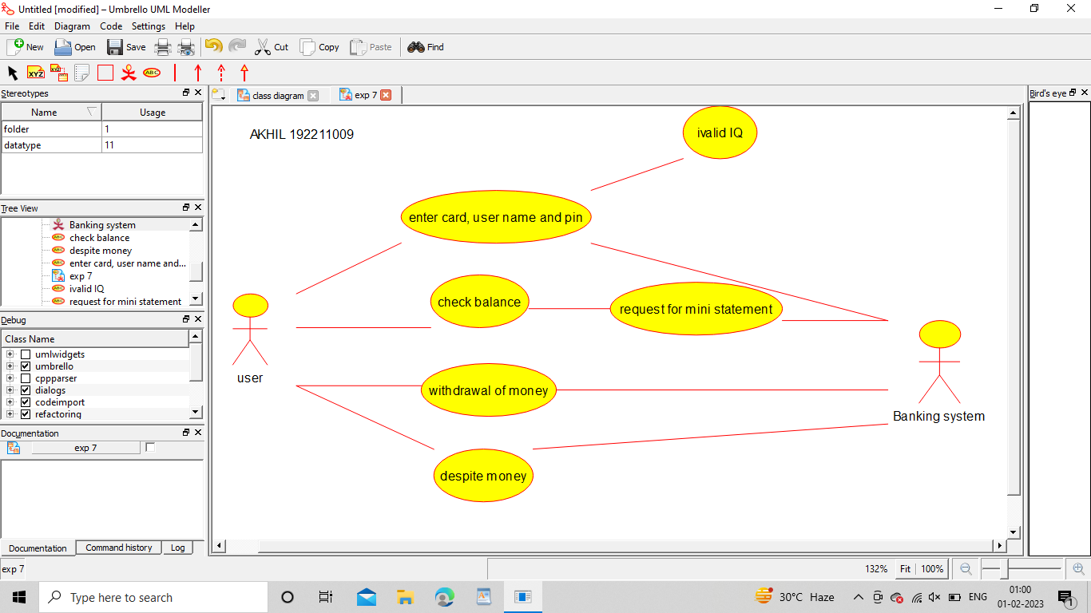

B. Nikhil Vardhan

192211805

**Result :** Use case diagram for ATM system was completed successfully.

**8Q. Draw a USE-CASE diagram for Online college management System using CASE tools.**

**Aim:** To draw a use case diagram for online college management system.

**Software Used:** Umbrello.

**Diagram:**

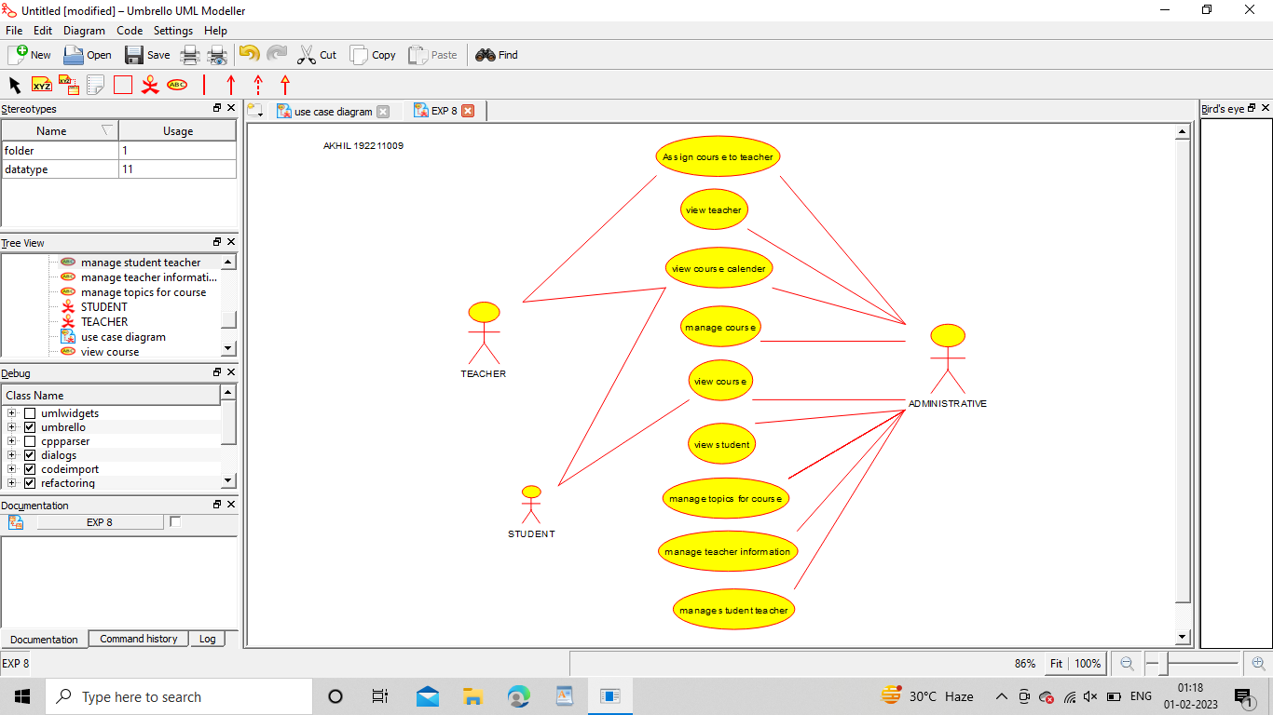

B. Nikhil Vardhan

192211805

**Result :** Use case diagram for online college management system was successfully completed.

**9Q. Draw a USE-CASE diagram for Online Airline Reservation System using CASE tools.**

**Aim:** To draw a use case diagram for online airline reservation system.

**Software Used:** Umbrello

**Diagram:**

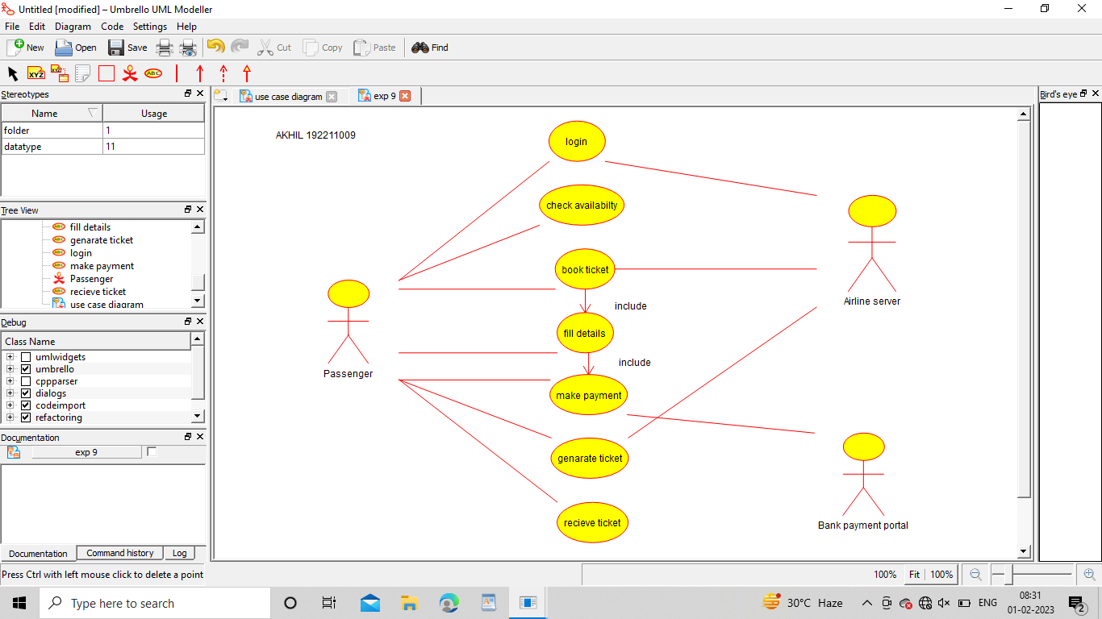

B. Nikhil Vardhan

192211805

**Result:** Use case diagram for online airline reservation system was successfully completed.

**10Q. Draw a Class diagram for Online Airline Reservation System**

**using CASE tools.**

**Aim:** To draw a class diagram for online airline reservation system.

**Software Used:** Umbrello.

**Diagram:**

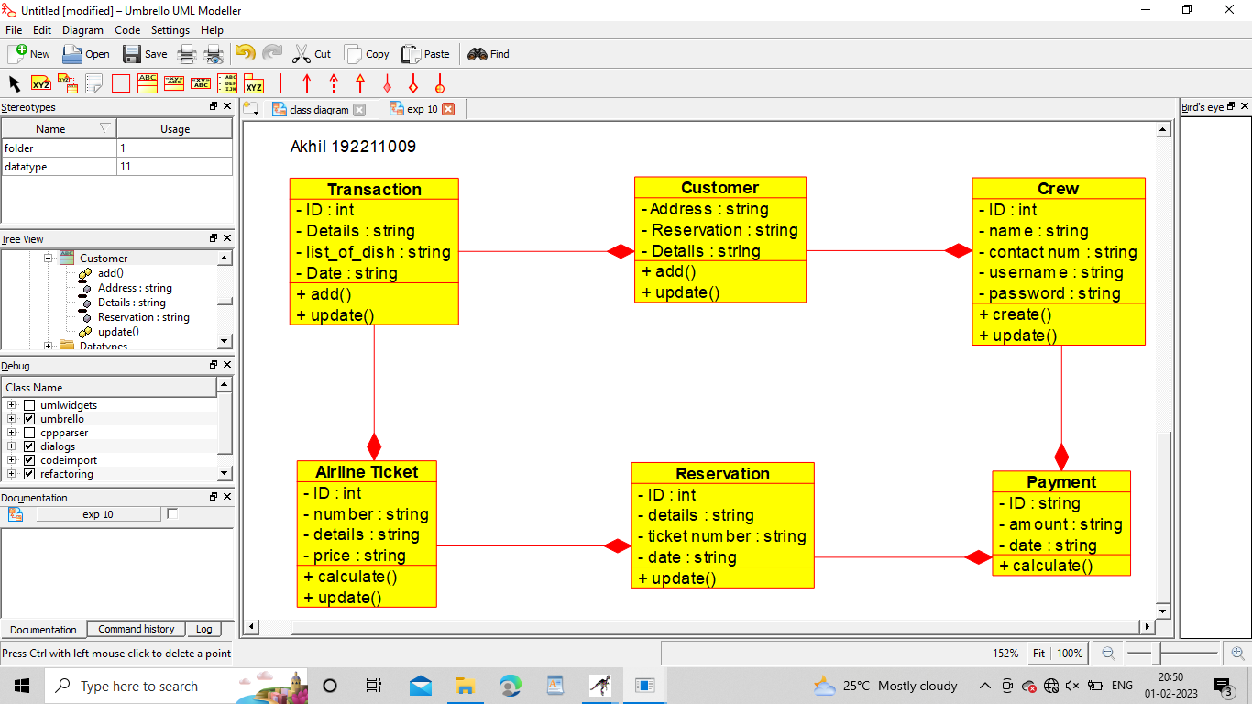

B. Nikhil Vardhan

192211805

**Result:** Class diagram for online airline reservation system was successfully completed.

**11Q. Draw a Class diagram for Online Voting System using CASE tools**

**Aim:** To draw a class diagram for online voting system.

**Software Used:** Umbrello.

**Diagram:**

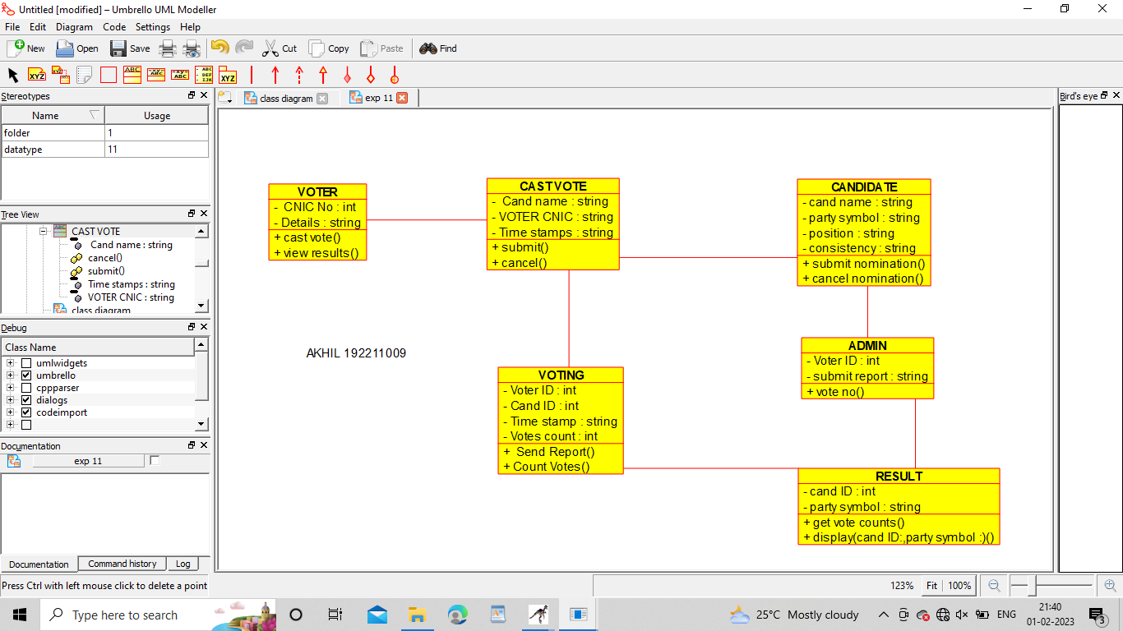

B. Nikhil Vardhan

192211805

**Result:** Class diagram for online voting system was successfully completed.

**12Q. Draw a Class diagram for Library Management System using CASE tools.**

**Aim:** To draw a class diagram for library management system.

**Software Used:** Umbrello.

**Diagram:**

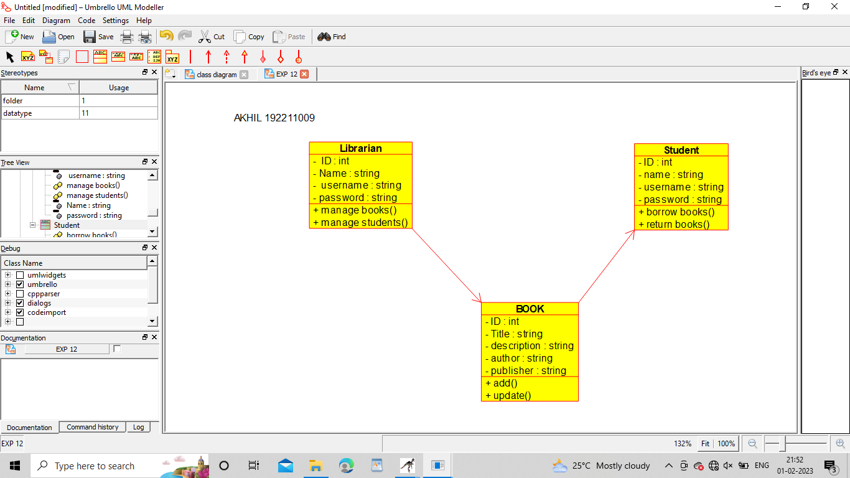

B. Nikhil Vardhan

192211805

**Result:** Class diagram for library management system was successfully completed.

**13Q. Draw a Activity diagram for Online Voting System using CASE tools.**

**Aim:** To draw a activity diagram for online voting system.

**Software used:** Umbrello.

**Diagram:**

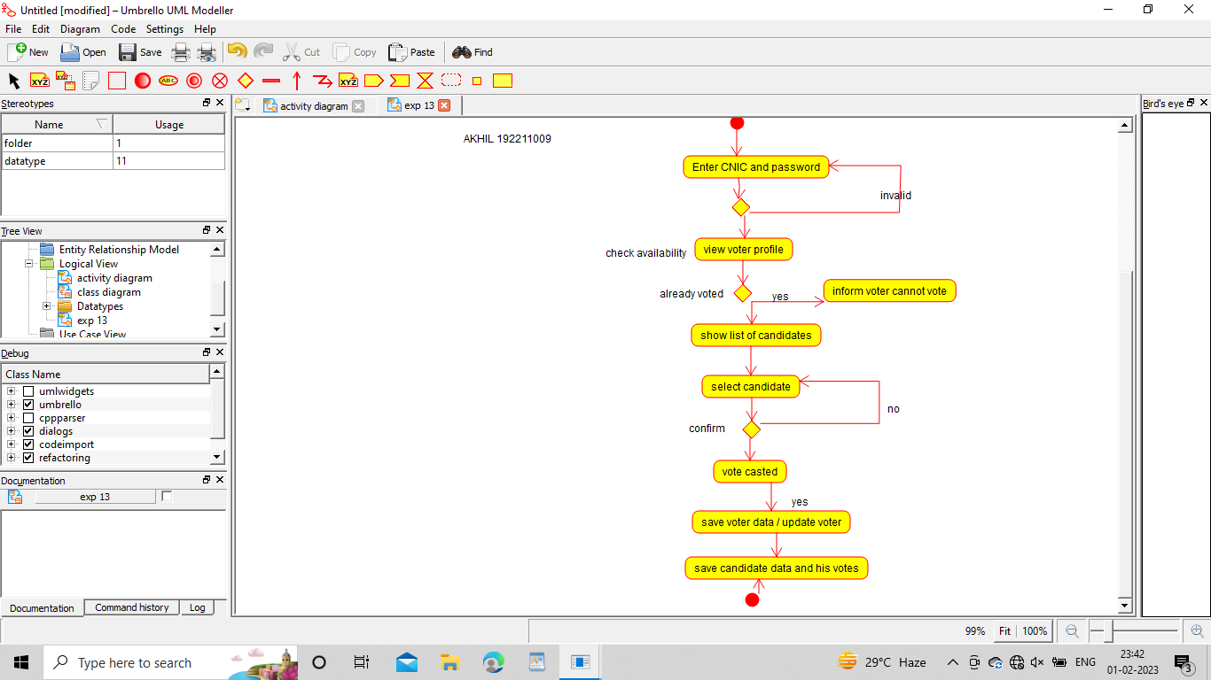

B. Nikhil Vardhan

192211805

**Result:** Activity diagram for online voting system was successfully completed.

**14Q. Draw a Activity diagram for Library Management System using CASE tools.**

**Aim:** To draw a activity diagram for library management system

**Software used:** Umbrello.

**Diagram:**

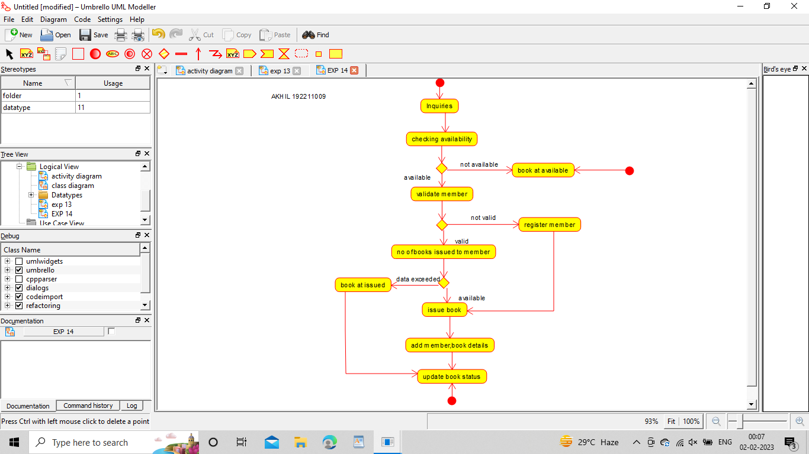

B. Nikhil Vardhan

192211805

**Result:** Activity diagram for library management system was successfully completed.

**15Q. Draw a Activity diagram for Online Shopping system using CASE tools.**

**Aim:** To draw a activity diagram for online shopping system.

**Software used:** Umbrello.

**Diagram:**

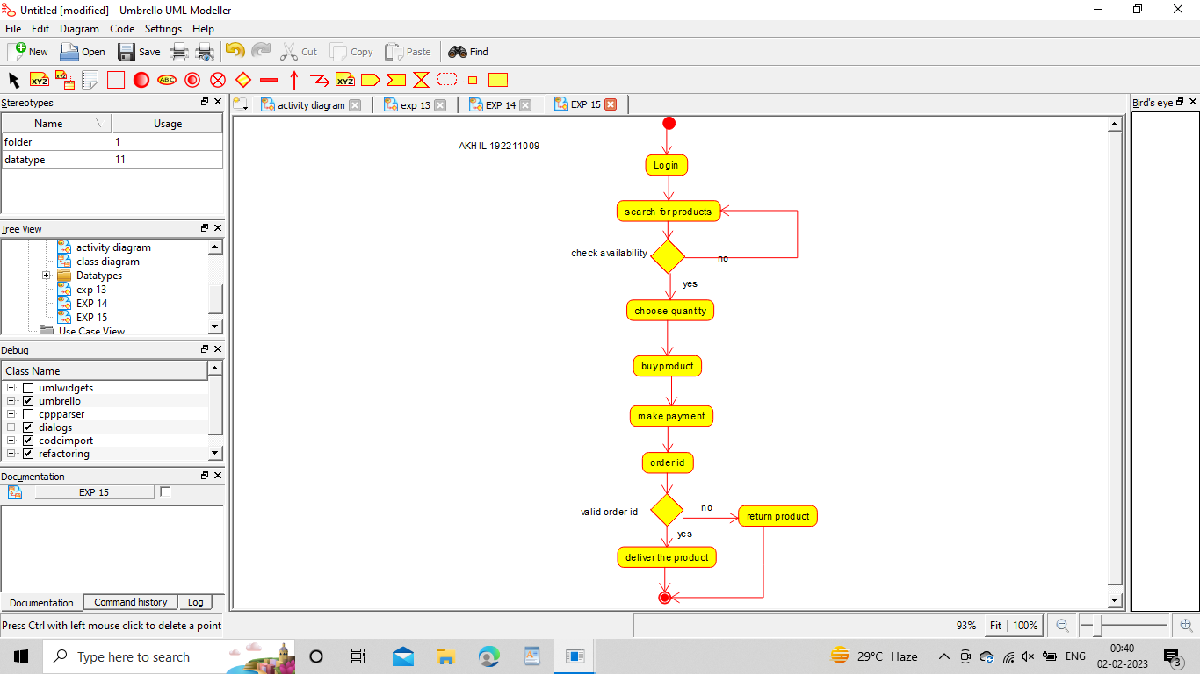

B. Nikhil Vardhan

192211805

**Result:** Activity diagram for online shopping system was successfully completed.

**16Q. Draw a Activity diagram for Online Railway Reservation System using CASE tools.**

**Aim:** To draw a activity diagram for online railway reservation system.

**Software used:** Umbrello.

**Diagram:**

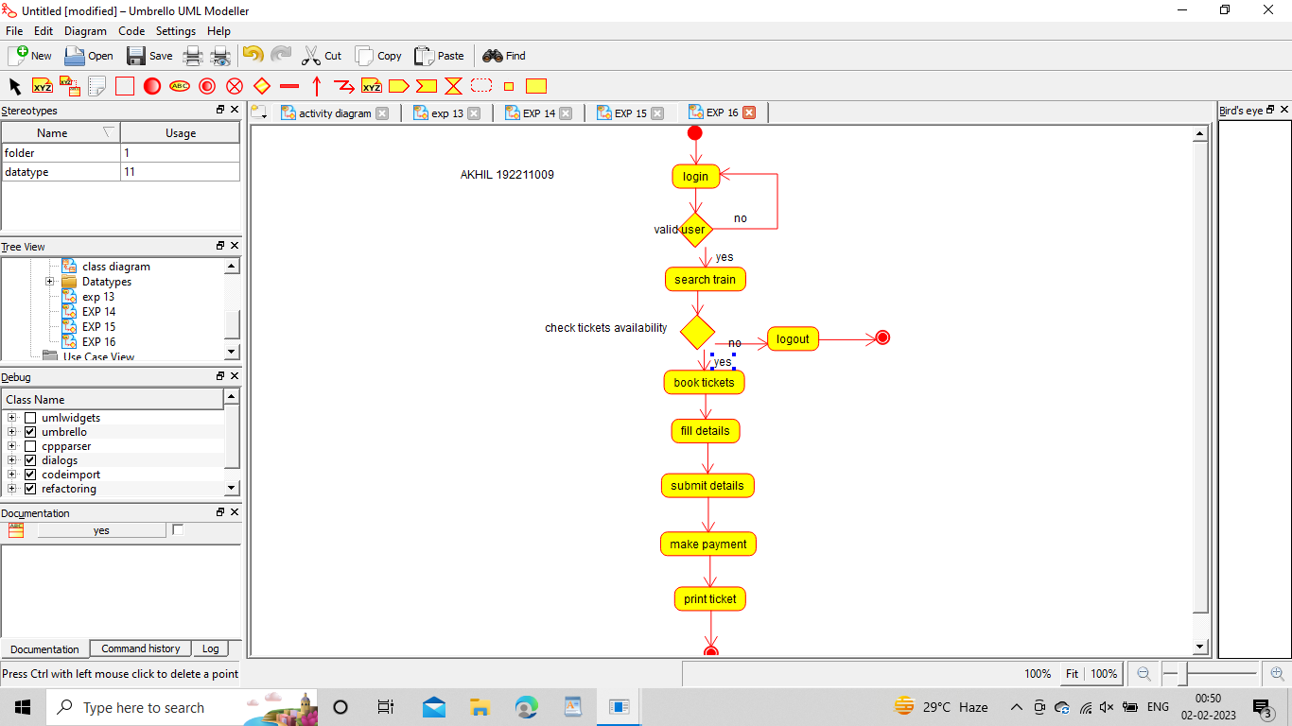

B. Nikhil Vardhan

192211805

**Result:** Activity diagram for online railway reservation system was successfully completed.

**17Q. Draw a Activity diagram for Hospital Management System using CASE tools.**

**Aim:** To draw a activity diagram for hospital management system.

**Software used:** Umbrello.

**Diagram:**

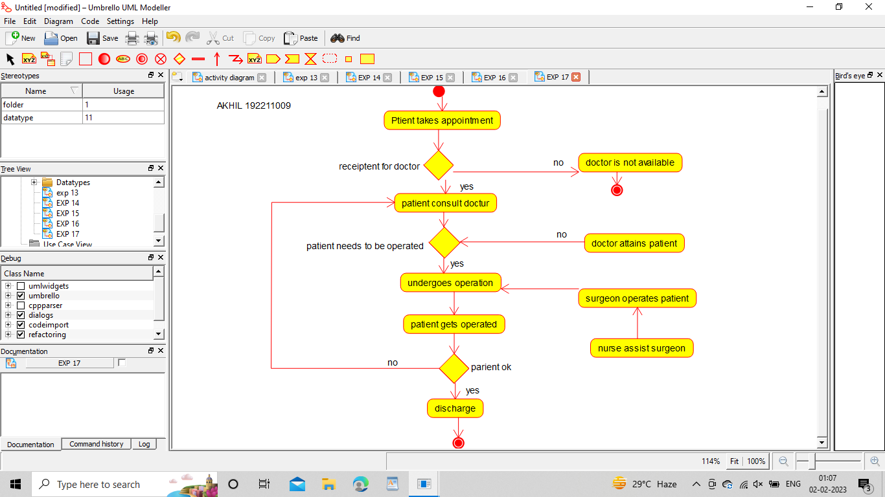

B. Nikhil Vardhan

192211805

**Result:** Activity diagram for hospital management system was successfully completed.

**18Q. Using Raptor- Draw the flowchart to check whether the given number is a palindrome or not.**

**Aim:** To draw the flowchart to check whether the given number is a palindrome or not.

**Software used:** Raptor.

**Diagram:**

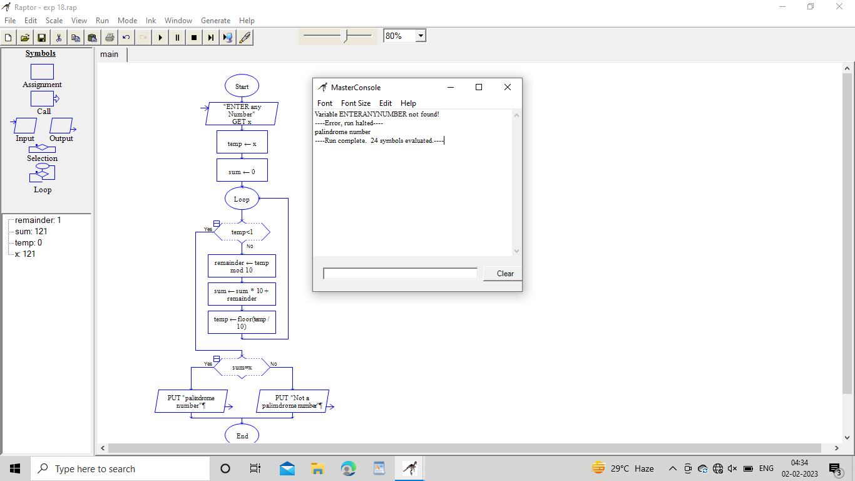

B. Nikhil Vardhan

192211805

**Result:** Flowchart to check whether the given number is palindrome or not was completed and output verified.

19Q.Using Raptor – Draw and validate the flowchart to swap two characters.

***AIM:***

To draw and validate the flowchart to swap two characters.

***SOFTWARE USED:***

**Raptor**

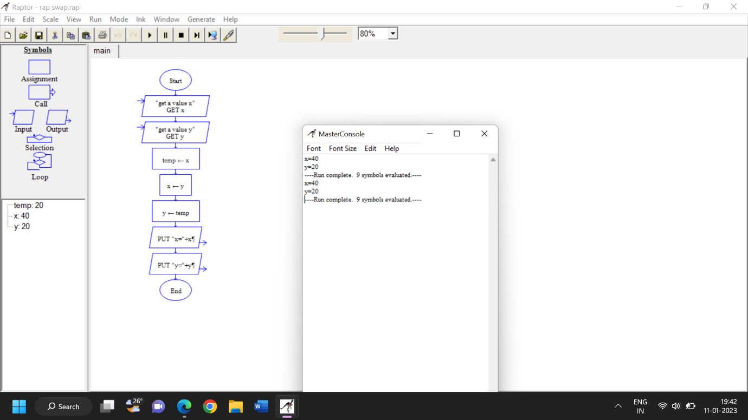

B. Nikhil Vardhan

192211805

***RESULT:***

To draw and validate the flowchart to swap two characters was successfully completed.

20Q.Using Raptor – Draw the flowchart to display the length of the string.

***AIM:***

To draw and validate the flowchart to display the length of the string.

***SOFTWARE USED:***

**Raptor**

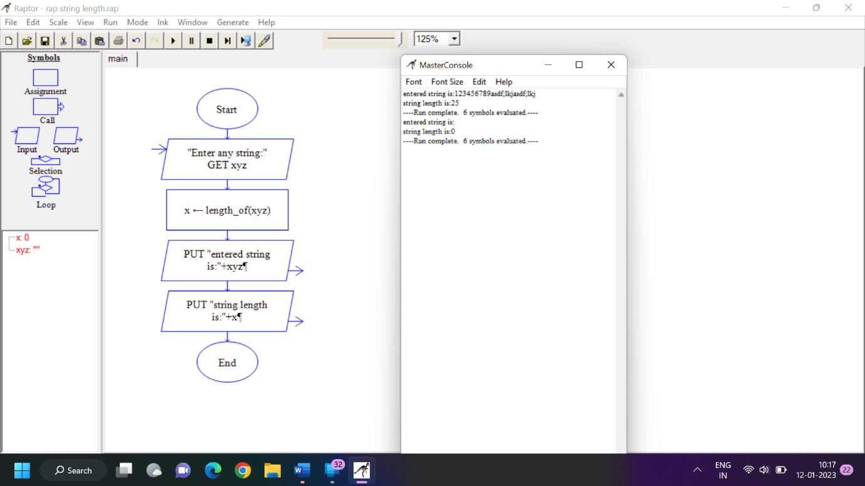

B. Nikhil Vardhan

192211805

***RESULT:***

To draw and validate the flowchart to display the length of the string was successfully completed.

**21Q. . Using Raptor - Draw the flowchart to find whether the given number is prime or not.**

**Aim:** To draw the flowchart to find whether the given number is prime or not.

**Software used:** Raptor.

**Diagram:**

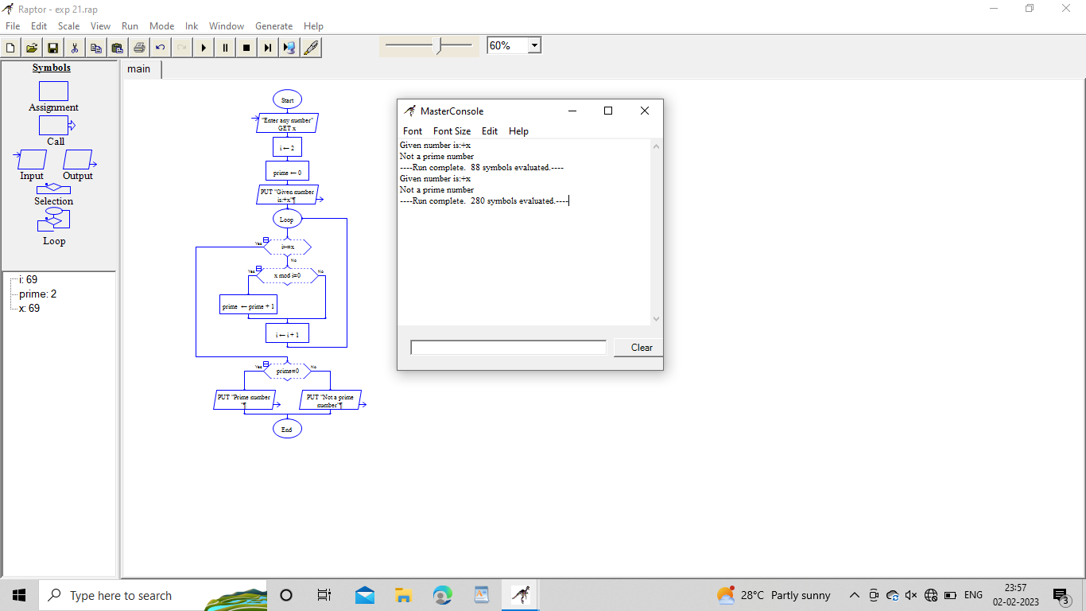

B. Nikhil Vardhan

192211805

**Result:** Flowchart to find whether the given number is prime or not was completed and output verified.

**22Q.** . Find Cyclomatic Complexity for a graph having number of edges as 13, number of nodes as 17 and number of predicate flow graph as 5.

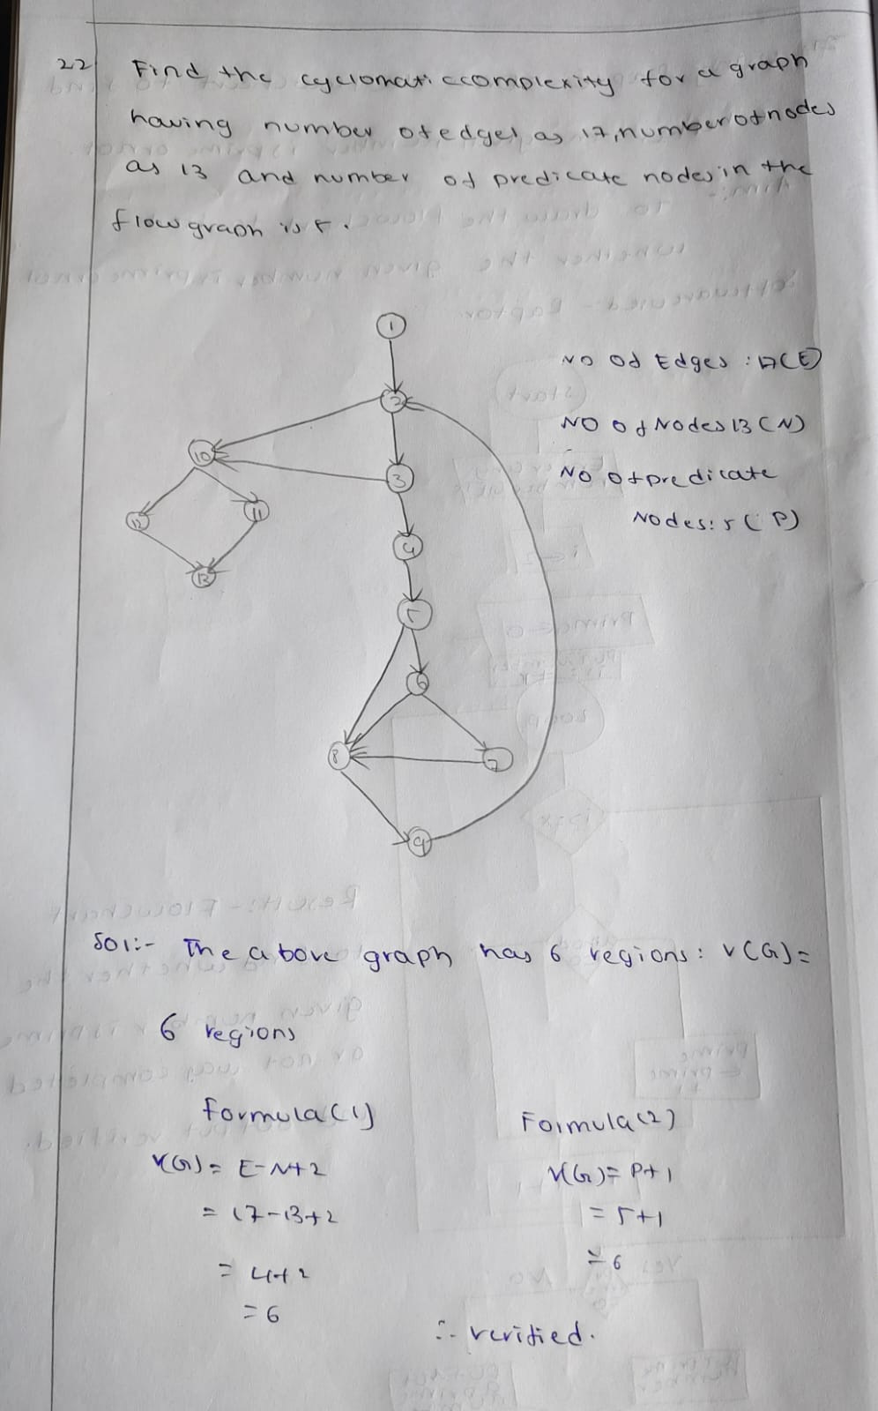

23. Draw an Activity diagram for Online banking System using CASE tools.

***AIM:*** To draw an Activity diagram for Online banking system

***SOFTWARE USED:***UMBRELLO:

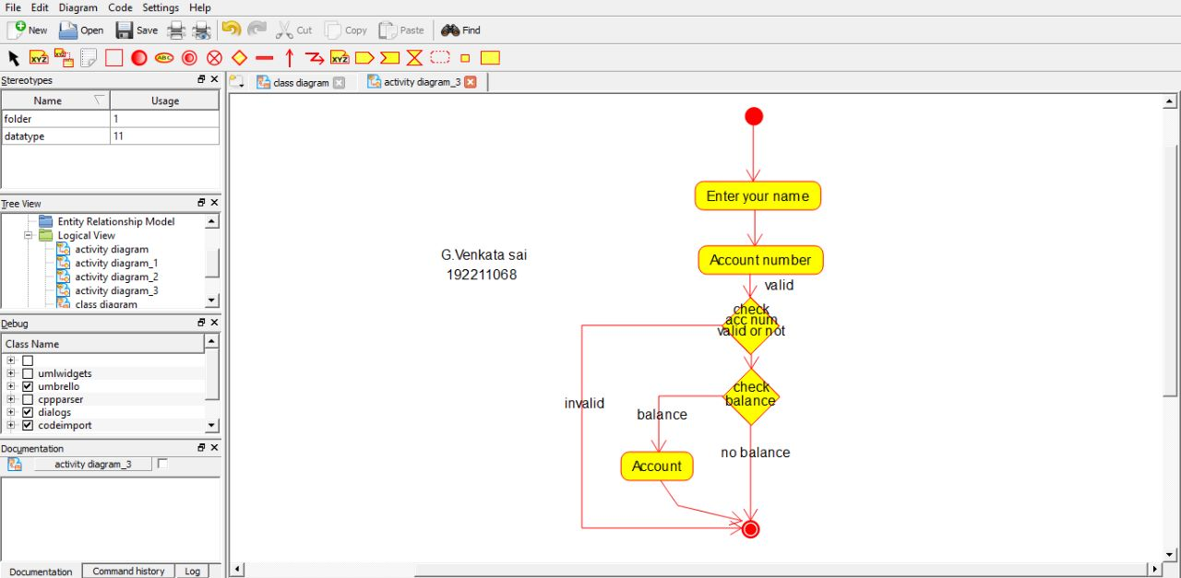

B. Nikhil Vardhan

192211805

***RESULT:*** Activity diagram for Online banking System was successfully completed.

**24.Draw a Activity diagram for e- Library online public access catalog System using CASE tools.**

**Aim:** To draw a Activity diagram for e Library online public access catalogSystem.

**Software used:** Umbrello.

**Diagram:**

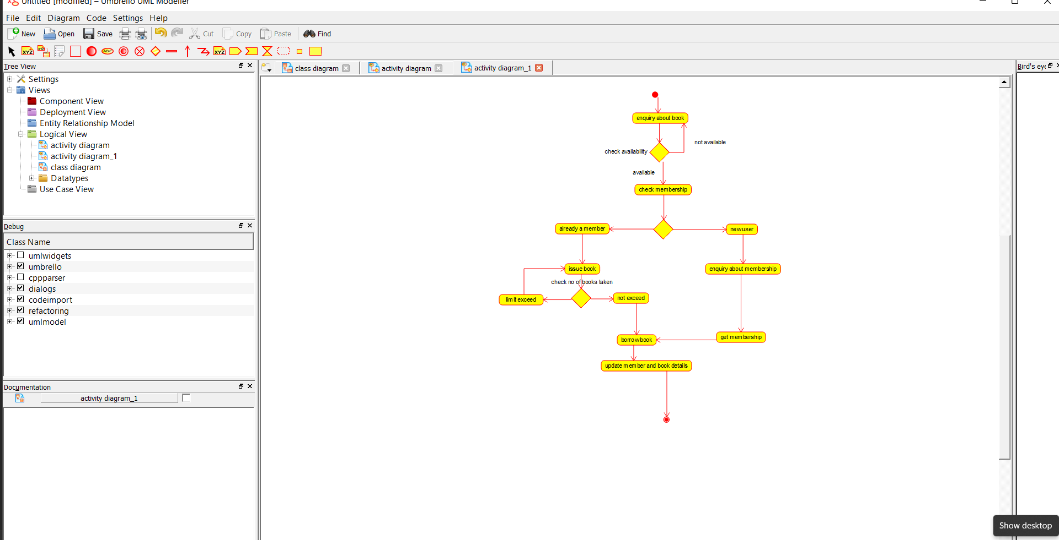

B. Nikhil Vardhan

192211805

**Result:** Activity diagram for e- library system was successfully completed.

**25.Draw a class diagram for e- Library online public access catalog System using CASE tools.**

**Aim:** To draw a class diagram for e Library online public access catalogSystem.

**Software used:** Umbrello.

**Diagram:**

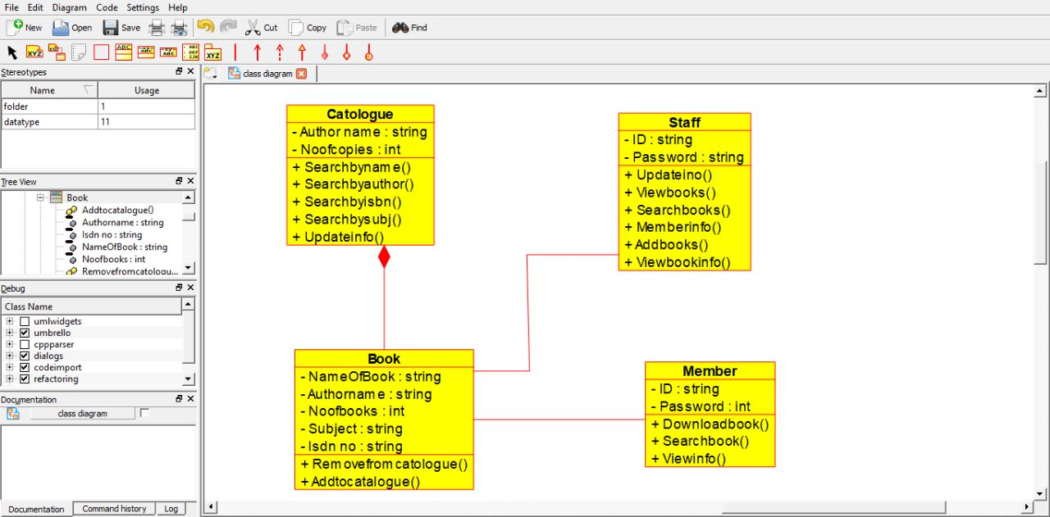

B. Nikhil Vardhan

192211805

**Result:** class diagram for e- library system was successfully completed.

**26Q.Draw a use case diagram for a restaurant system. The activity of the restaurant system is listed below. Receive the customer food orders, serve the customer with their ordered food, collect payment from customers, store customer payment details, order raw materials for food products, pay for raw materials and pay for labour.**

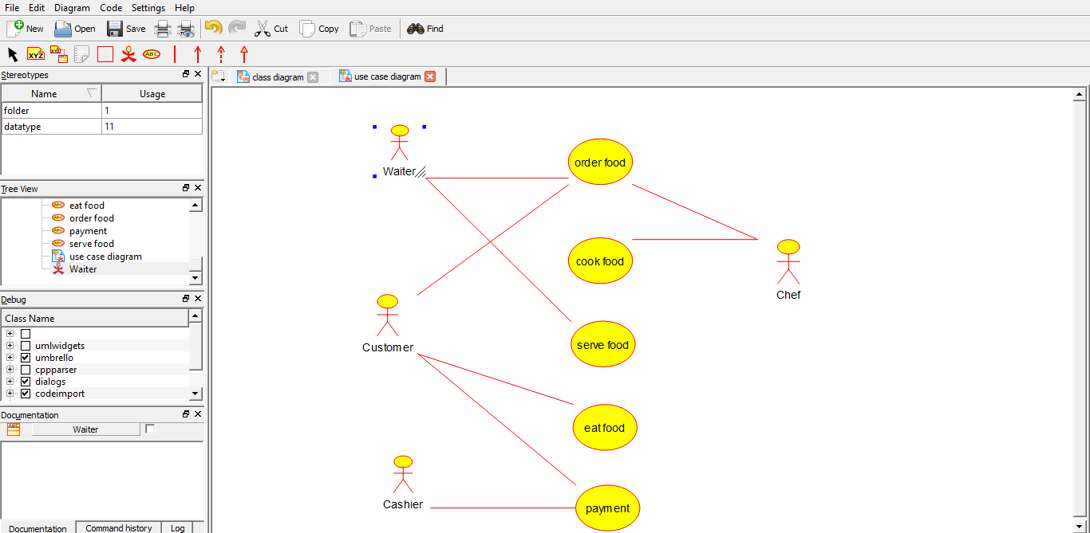

B. Nikhil Vardhan

192211805

**27Q. Draw a class diagram for a restaurant system. The restaurant system is listed below. Receive the customer food orders, serve the customer with their ordered food, collect payment from customers, store customer payment details, order raw materials for food products, pay for raw materials and pay for labour.**

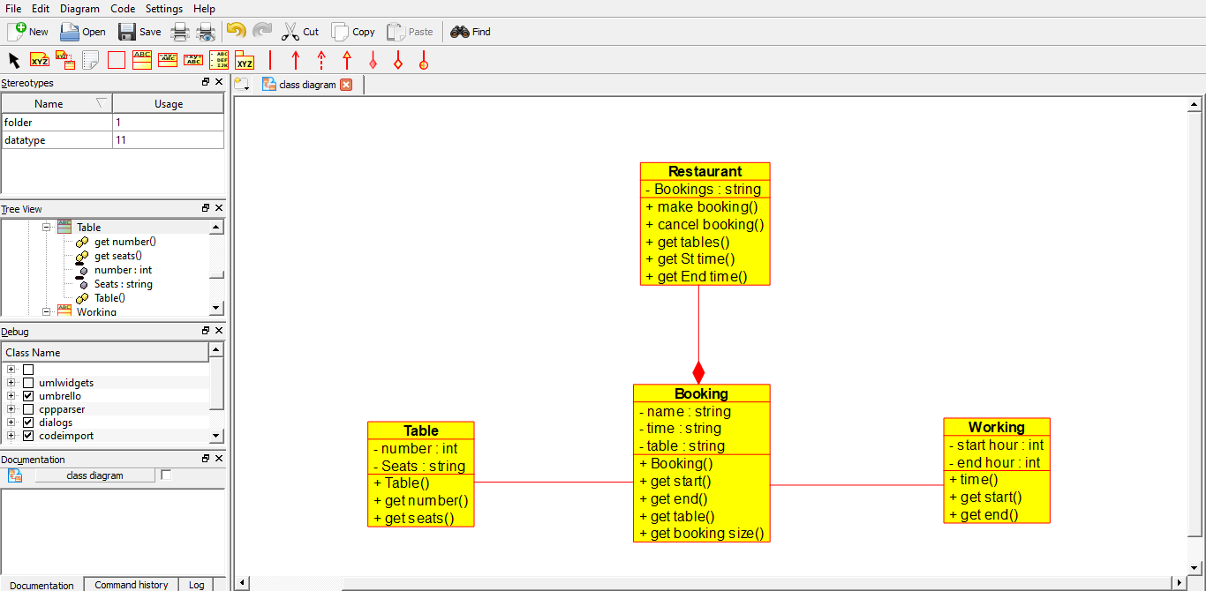

B. Nikhil Vardhan

192211805

**28Q.Make a class diagram to model for a quiz system. The user can request a quiz system. A user can request a quiz for the system. The system picks a set of questions from its database, and composes them together to make a quiz. It rates the user’s answers and gives hits if the user requests it. In addition to users, we also have helpers who provide questions and hints. And administrators who must certify questions to make sure they are not too big, and that they are correct.**

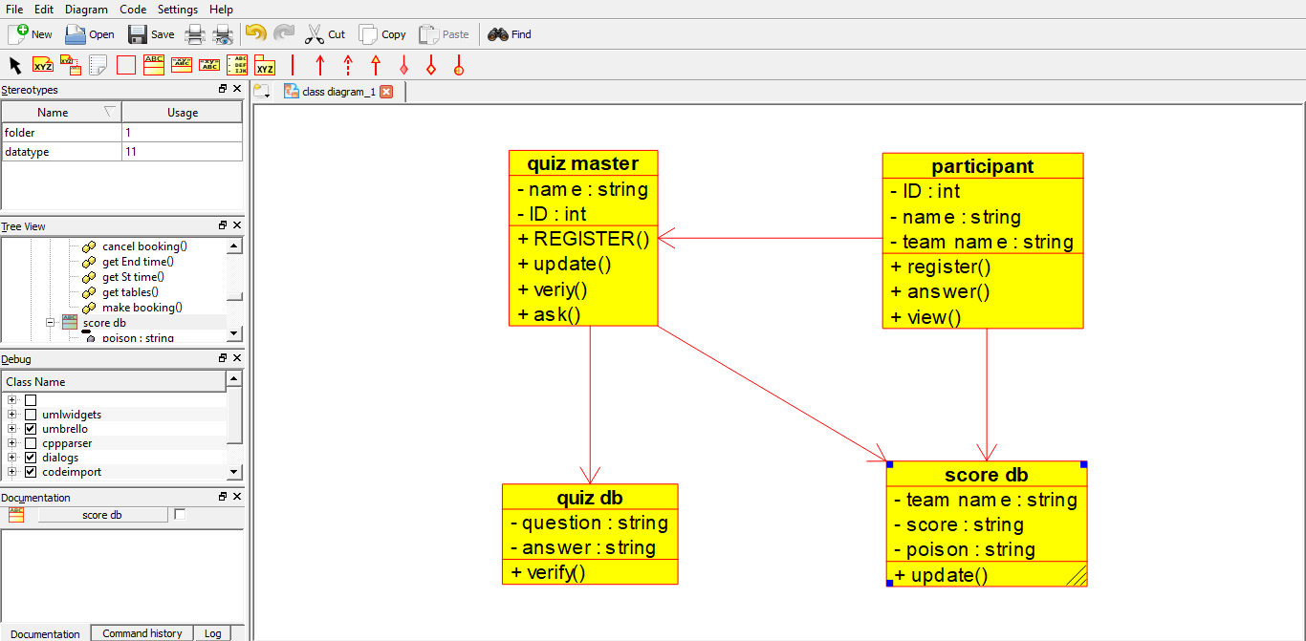

B. Nikhil Vardhan

192211805

**29Q.Draw a use case diagram to model for a quiz system. A user can request a quiz system. A user can request a quiz for the system. The system picks a set of questions from its database, and composes them together to make a quiz. It rates the user’s answers and gives hits if the user requests it. In addition to users, we also have helpers who provide questions and hints. And administrators who must certify questions to make sure they are not too trival, and that they are correct.**

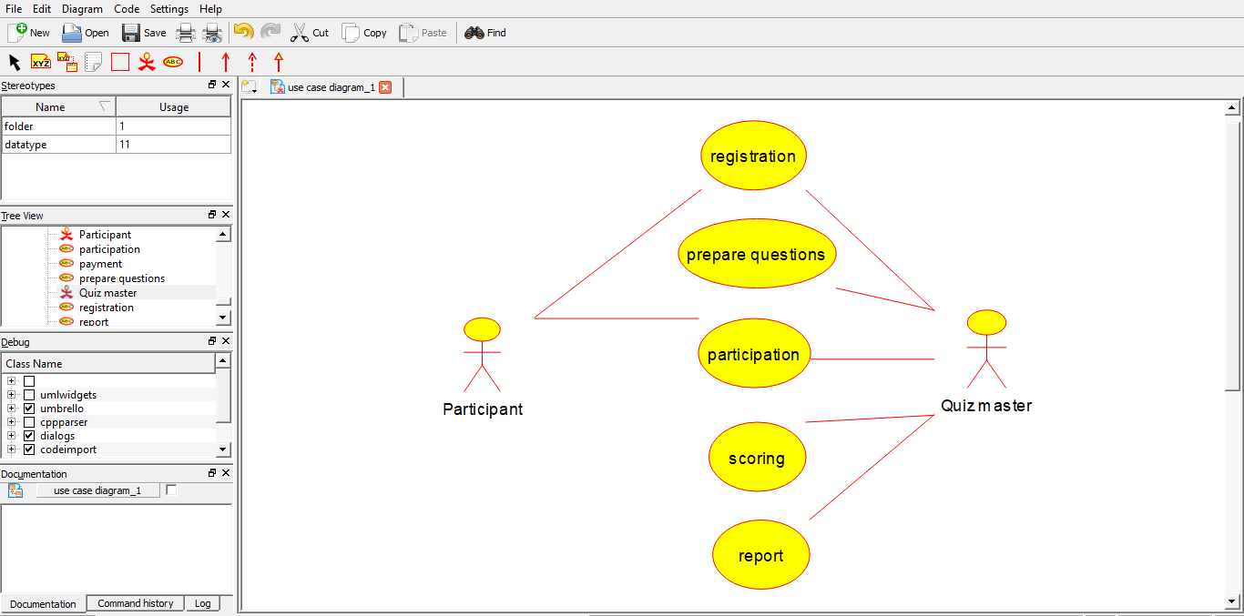

B. Nikhil Vardhan

192211805

**30Q.Using Raptor-Draw and validate the flow chart to calculate factorial of a number.**

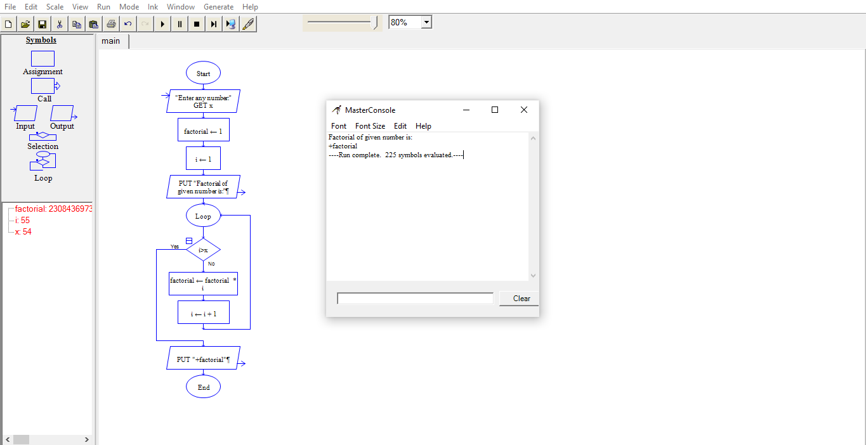

B. Nikhil Vardhan

192211805

**31. Using Raptor – Draw and validate the flowchart to find odd series of the given number.**

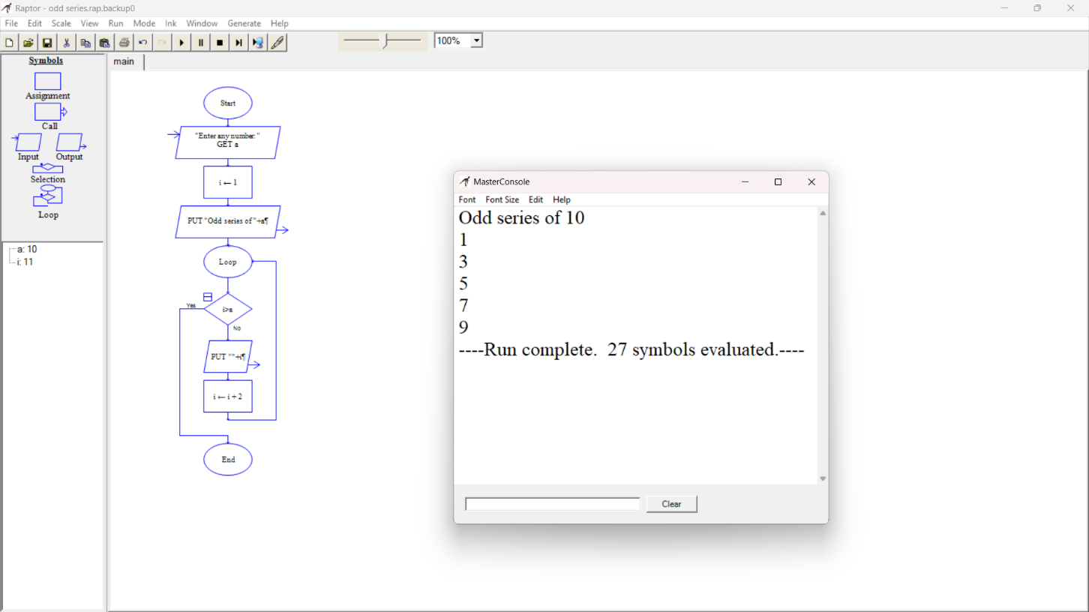

B. Nikhil Vardhan

192211805

**Using Raptor – Draw and validate the flowchart to find even series of the given number.**

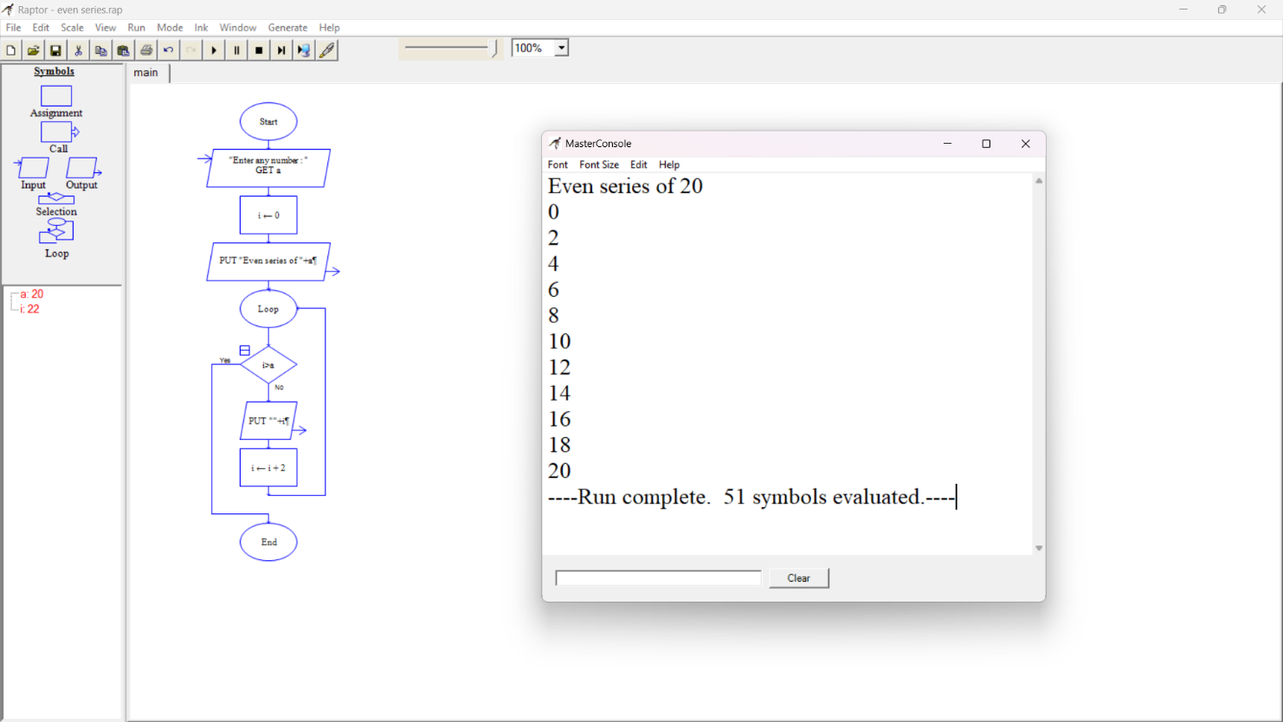

B. Nikhil Vardhan

192211805

**32Q. .Using Raptor-Draw and validate the flow chart to display the reverse of the string.**

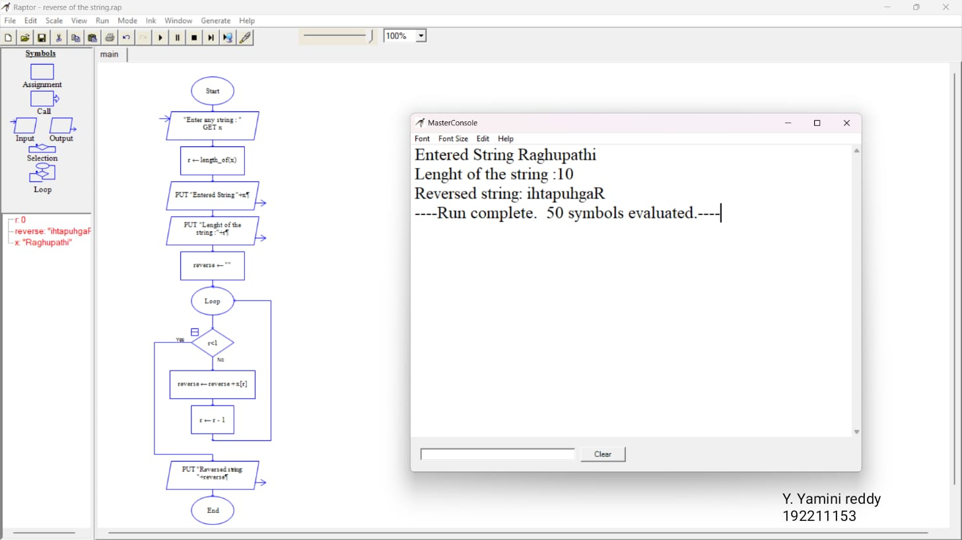

B. Nikhil Vardhan

192211805

**33Q. Using Raptor-Draw and validate the flow chart to find largest of n Numbers.**

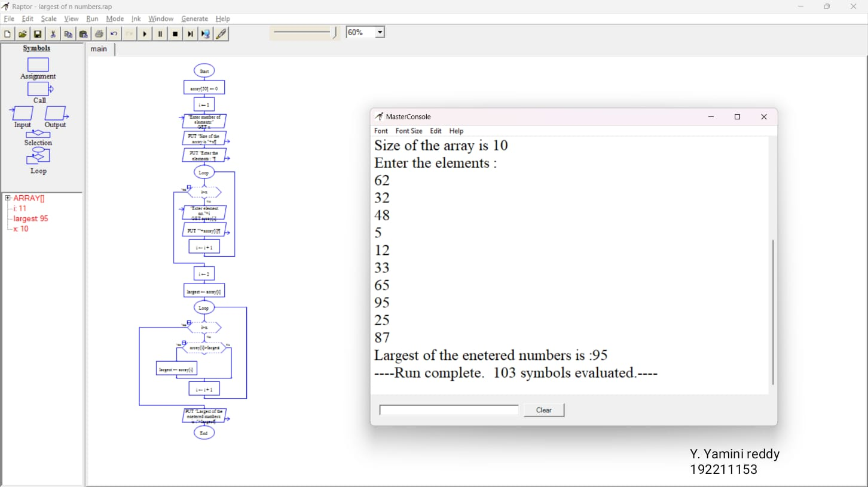

B. Nikhil Vardhan

192211805

**34Q.Find cyclomatic complexity for a graph having number of edges as 20,number of nodes as 15 and number of predicate nodes in the flow graph as 4.**

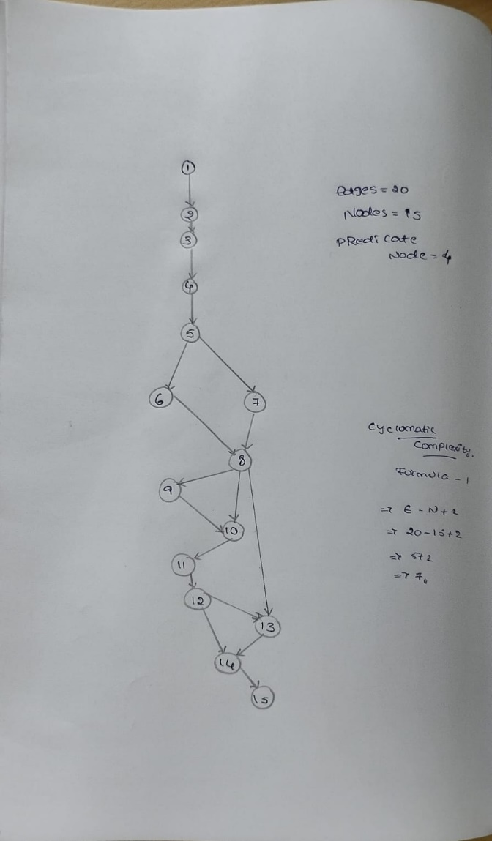

**35Q. Using Raptor- Draw and validate the flowchart to calculate Fibonacci series.**

**Aim:** To draw and validate the flowchart to calculate Fibonacci series.

**Software used:** Raptor.

**Diagram:**

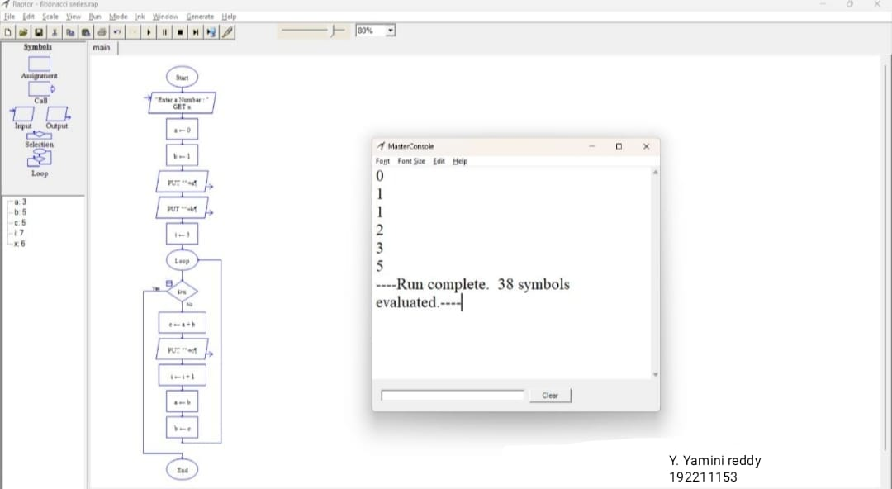

B. Nikhil Vardhan

192211805

**Result:** Flowchart to calculate Fibonacci series was completed and output verified

**36Q.using Raptor-Draw the flowchart to find smallest of n Numbers.**

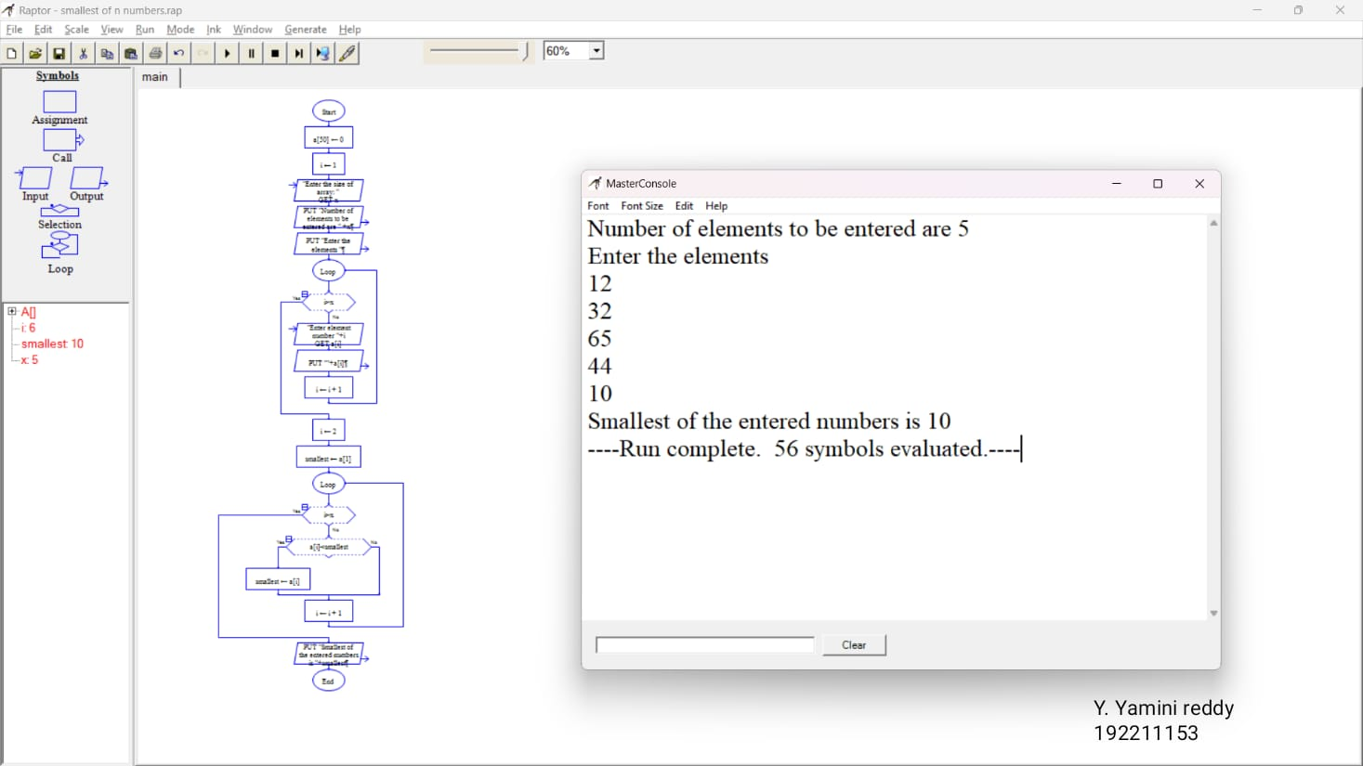

B. Nikhil Vardhan

192211805

**37Q.Draw use case diagram for E-wallet online prepaid account.**

**Aim:**To draw a use case diagram for E-wallet online prepaid account

**Software used:**umbrello

**Diagram:**

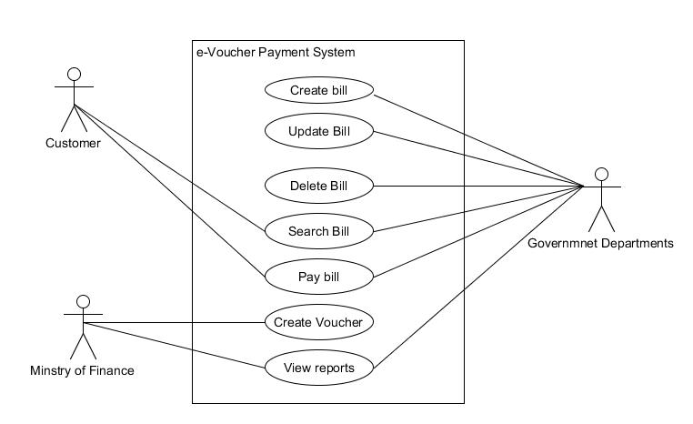

**Result:** use case diagram for E-wallet online prepaid account was completed successfully.

**38Q. Draw a class diagram for online security management system**

**Aim:**To draw a class diagram for online security management system

**Software used:**umbrello

**Diagram:**

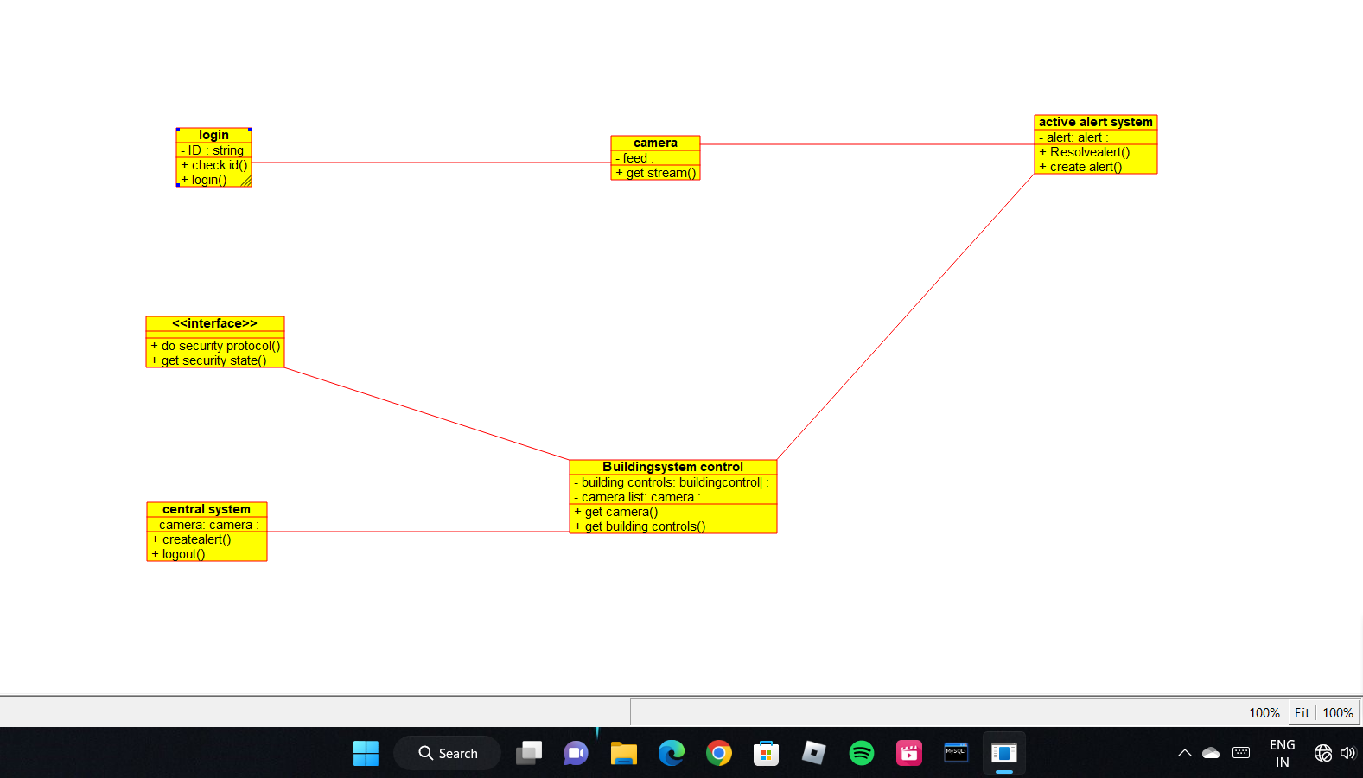

B. Nikhil Vardhan

192211805

**Result:** Class diagram for online security management system was successfully completed

**39Q. . Draw a Class diagram for Online Voting System using CASE tools**

**Aim:** To draw a class diagram for online voting system.

**Software Used:** Umbrello.

**Diagram**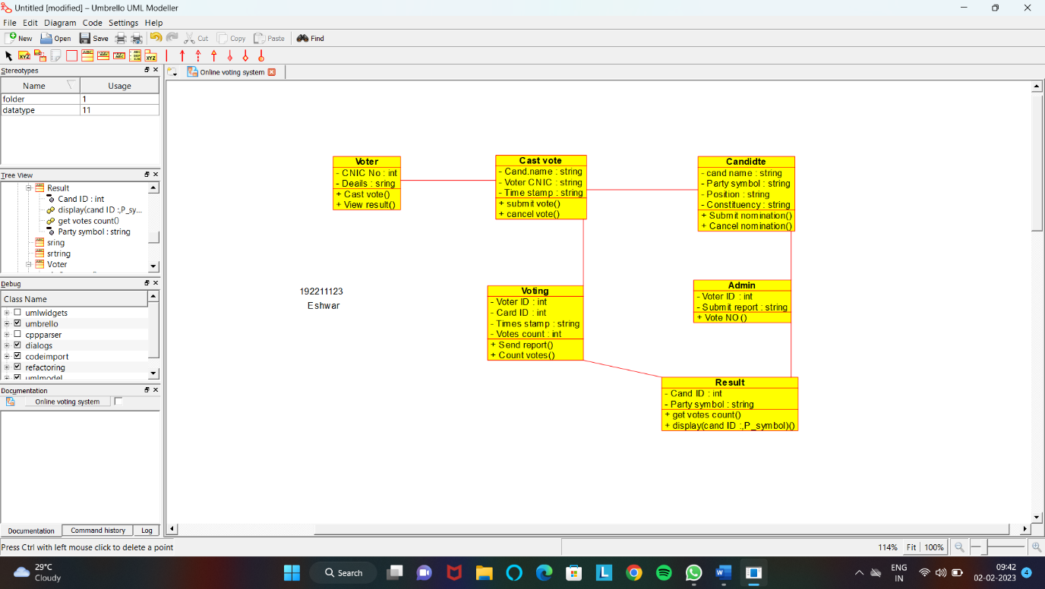

B. Nikhil Vardhan

192211805

**Result:** Class diagram for online voting system was successfully completed.

**40Q. Using Raptor- Draw the flowchart to check whether the given number is a palindrome or not.**

**Aim:** To draw the flowchart to check whether the given number is a palindrome or not.

**Software used:** Raptor.

**Diagram:**

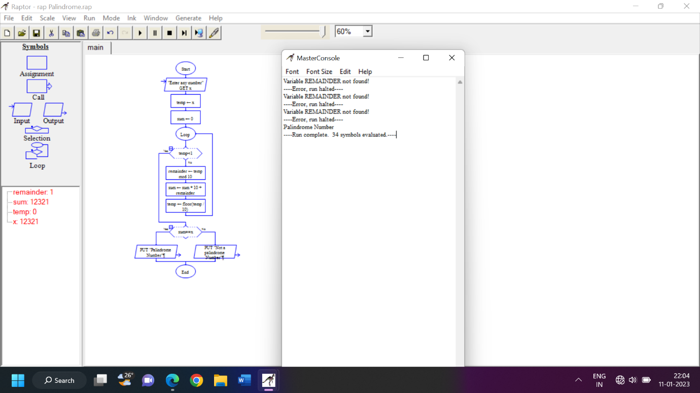

B. Nikhil Vardhan

192211805

**Result:** Flowchart to check whether the given number is palindrome or not was completed and output verified.